Reynold's SPADE Documentation

The original Reynold's Experiment

Reynolds (1999) argues that the large uncertainty about the true resource size makes it impossible for producers to estimate the user cost. They therefore treat the resource as practically infinite and let the price be determined only by the current marginal cost. By assuming that the exploration success rate first increases due to better information, thereby reducing the finding cost, and then decreases as depletion becomes dominant, Reynolds concludes that exploration may give a false signal of decreasing scarcity. The mechanism behind the information effect on the success rate is further investigated in an experimental game setup with human players

The orginal Reynold's experiment was a game he devised to play with his students. There was a defined 'world' comprising of a number of 'oil regions' each with the same number of potential sites. Each site was imbued with oil and the students tried to find oil by spending some of their budget, and if they successfully found oil they would receive a reward. 1 currency unit to explore, 3 currency units for success. This set of experiments is based upon this initial idea and hypothesis. By using agents we can run many more runs than Reynold was able to do originally and in turn play with many different learning strategies to test the efficiency of computer agents against humans.

This series of experiments uses the SPADE agent framework based upon the Python prgoramming language to build a multi-agent system replicating the human experiment. The benefit of using this specific framework is because the communications infrastructure for the framework is based upon a common messaging protocol, we will be able to mix human and computer agents together for some of the experiments.

Installing SPADE
SPADE is the Smart Python Agent Development Environment based upon the Jabber open instant messaging protocol and is FIPA compliant.

Installation
Grab the SPADE deliverable package at http://spade.gti-ia.dsic.upv.es. Uncompress it and launch the configure.py script in order to configure the platform. You can provide a parameter to this script, which is the machine's hostname and that will be used as the platform's name. Finally, launch the runspade.py script and see your platform rise before your eyes. After a few seconds you should see the green word Done on the screen confirming that the platform was succesfully launched. In a nutshell:

$ tar xvzf spade-2.0.0.tar.gz
$ cd spade
$ python configure.py myhost.myprovider.com
$ python runspade.py

And that's it. If everything went well, congratulations! You have succesfully installed SPADE! If something went wrong, don't panic!, head to chapter XX "Troubleshooting" for answers or follow the rest of this manual to know a lot more about SPADE.

Running

Before you can use the SPADE platform, the framework must be running. In the SPADE installation folder there is a python script called runspade.py. This script must be run from within python before you attempt to use any SPADE agents. It cannot be run from within a development platform, it must be run from within python itself.

The easiest way to do this is by right clicking on the runspade.py file

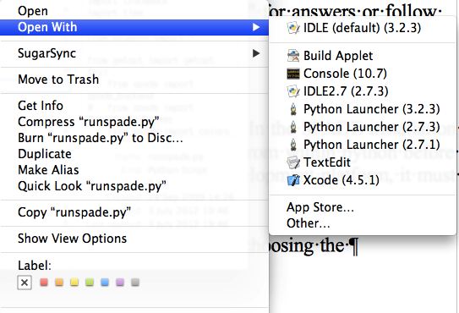

and choosing the 'Python Launcher 2.7.3' option under the 'Open With' context menu option.

If it has worked you should see the following terminal window.

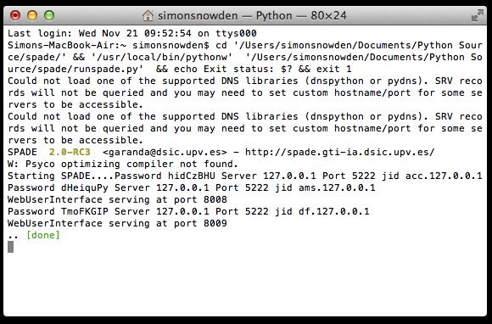
If you then enter the url http://127.0.0.1:8008 into a browser you should see

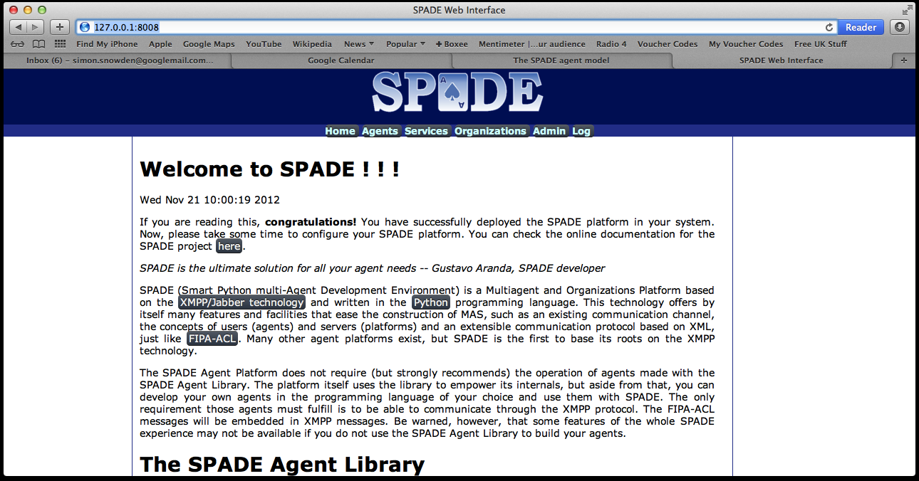
This proves that the SPADE platform is up and running.

Clicking the Agents option on the top menu will allow you to see the various agents that are running on the platform currently. At the minimum this will be the Directory Facilitator (df) and the Agent Management System (ams), see below.

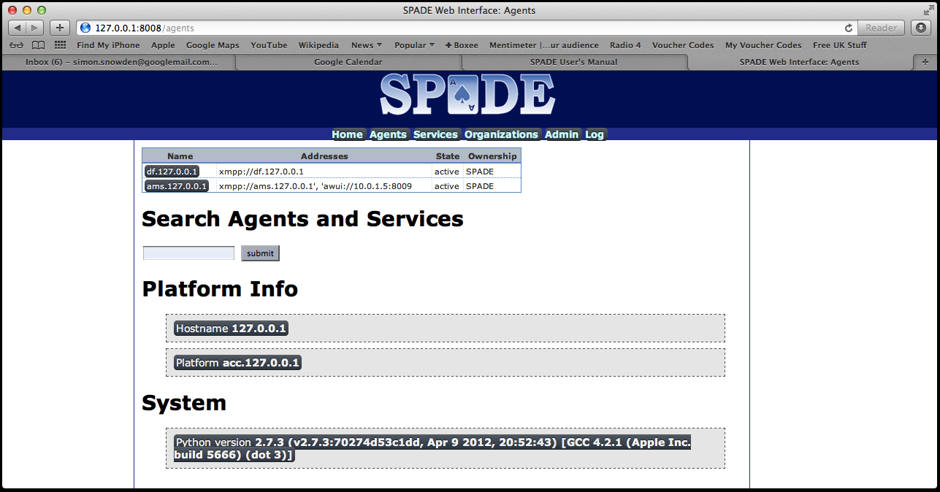

Manuals and documentation.
The manual is available at this url.

http://spade.gti-ia.dsic.upv.es/manuals/html-chunk/index.html

There is also an api guide available under the doc folder in the main SPADE folder.

Experiment Structure
The following defines the experimental stages this project will run through. The order is not set in stane and may change as the project progresses.

Experiment 1

Repeat 1st paper. This is to ensure that the Bayesian logic is correct and working as expected. Not a real experiment, simply a test of the new agent based framework over the previous MATLAB implementation.
- Implement Agent.
- Bayesian State – pessimism/optimism
- Bayesian learning algorithm – expectation of oil distributions.
- Choosing Site.
- Explore site
- Implement Environment
- Area for exploration
- Explored elements
- Success/failure for explored elements
- Unexplored area
- Oil Distributions
- What results are required?
- Expectations per exploration, per run, per area, per set of oil distribution
- The bayesian distributions. This is big, can be derived from previous expectations and success/failures
- Success failures/time
- Indirect cost, the inverse of the success rate.
- Chosen region/site, derived from success/failures. Therefore examine search patterns.

Need diagram for expectations data structure.

Experiment 2
Create the multi-agent version of experiment 1. Need to tyhink about the process of choosing the site.

Method 1

The agent asks the environment for unexplored sites, chooses one, tells the environment the one it is to explore, the environment confirms if still unexplored and returns the result (success/failure). There is potential here to introduce cost elements per the original Reynold's experiment. Could also play with if they know the other agents results. This will impact on the bayesian learning they will go through.

Method 2

Introduce a auction referee agent. The auction referee agent asks the explorer agents for their site of choice, referee negotiates site choice conflicts, referee then asks the environment agent for result of explorer agent's choice. Referee informs the explorer agents of their results. Referee asks for fresh choices. Again, think about playing with if the agents can see each other's results. This will impact on the bayesian learning they will go through.

Negotiations – can introduce bidding. Initially can simply compare their expectations. Higher expectations more likely to bid more. Or, first come first serve. In future, bid can be a combination of expectation and budget.

Should really introduce budgets at this level. The original Reynold's experiment required the explorer agent to pay 1 to explore, and received 3 for a success.

Need diagram for expectation parameters

Agent Bayesian out look mix.

A – All the same (go through the different Bayesian outlooks)
B – 50/50 of different combos
C – 25/25/25/25
D – 50/25/25

Will also need to play with the number of agents. Start low (approximately 10), then work up wards. This will also have a knock on effect on the area to be explored, and therefore the oil distributions.

Experiment 3

Now begin to explore some different learning algorithms.
Monte-carlo
Gas
Reinforcement
Any others

Match agents against one another (see the previous mix of Bayesian outlooks). Also begin to explore the idea of when to stop searching (get out whilst the going is good sort of thing).

Experiment 4
Repeat the original Reynold's experiment using human agents, but create an electronic version of the game, and capture the data electronically.

Experiment 5
Mix humans and agents in the environment.

Experiment 6
Now look at developing more complex agents made up of multiple explorer agents – self as multiple selves. This could use a form of triangulation to make choice of site to explore for example.

Experiment 7
Repeat 5 with 6.

Experiment 8
Now begin to look at the impact of beliefs on the functioning of processes. So for example the cost function can show the amount of resistance to change. So re-initialise the agents expectations part way through a run, in effect testing the impact of changing personnel (therefore different people with different belief systems) on a given process (how much instability is introduced?). Try this with different personality types, does the difference in ratio of pessimism/optimism impact on how rapidly the system returns to stability?

Experiment 9
The same as the above, but this time keep the agent's expectations the same, but reset the oil distribution. Mimic a maintenance of personality, but a change to the process.

Experiment 10
Same as the above, but change both expectations and distributions.

Application Structure

Database Structure
The database management system to be used with Reynold's SPADE is MySQL. This is an open source tool and freely available for this educational type of development. The next section details installing the tool and then details the database structure for Reynold's SPADE.

Installing MySQL

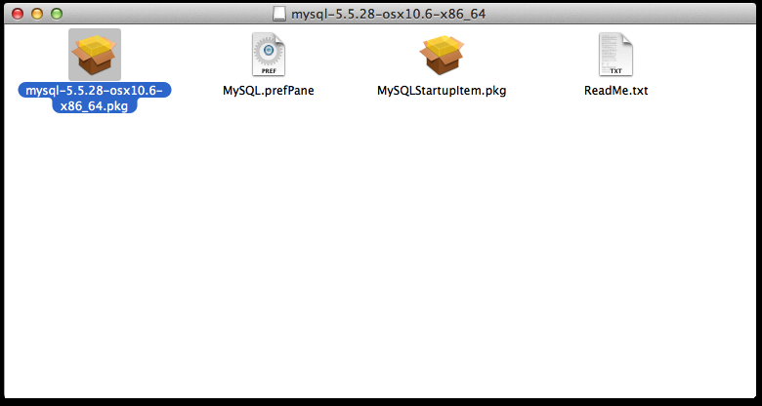
Got to the MySQL web site (http://www.mysql.com/products/community/) and down load the community edition (it is free to use).

Run the DMG file, a Finder window should appear with 4 files in it. Double click the

mysql-5.5.28-osx10.6-x86_64.pkg file and follow the installation instructions. Once MySQL has been successfully installed you now need to install the preference pane, so double click the MySQL.prefpane file and follow the instructions. From system settings you can now access the startmysql command (see below).

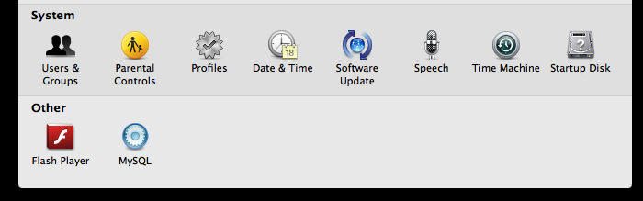
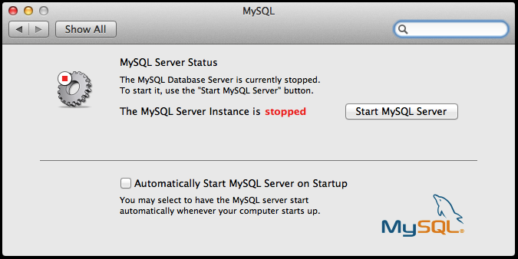
A MySQL client now requires installing. Suggest using the MySQL Workbench application. Go to the Workbench site (http://www.mysql.com/downloads/workbench/) and download the appropriate file. Run the DMG file downloaded and you will see the following screen. Drag the MySQL icon on to the applications ican and Workbench will be installed.

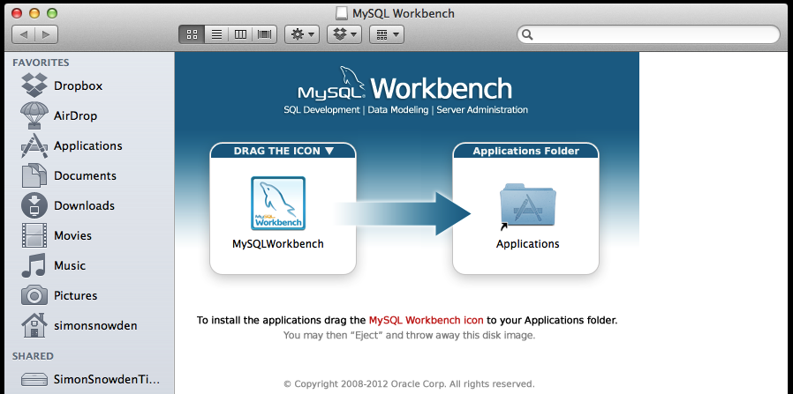
You should now have the MySQL server installed and a very good client to manage the MySQL server visually.

Agent Structure

Object Structure

